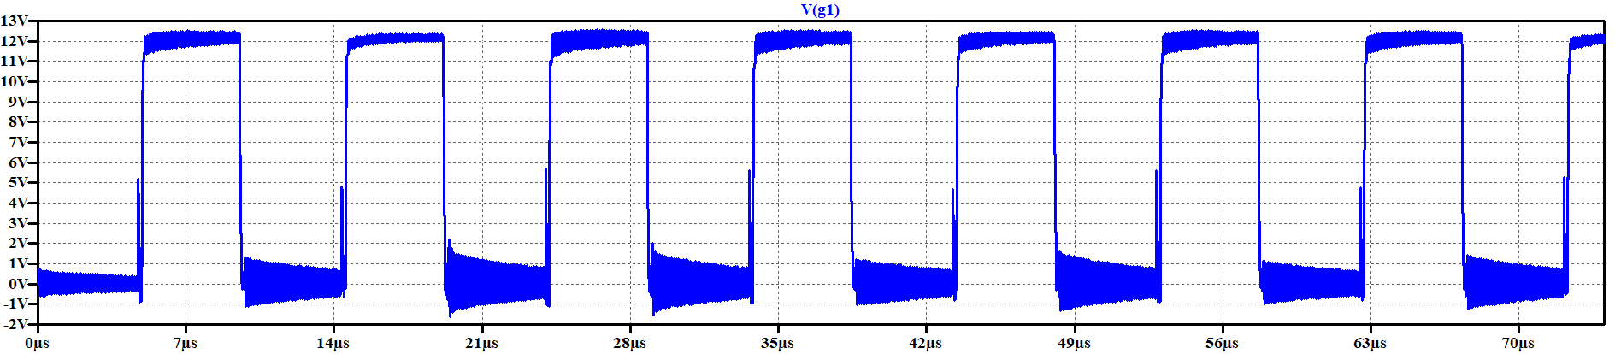

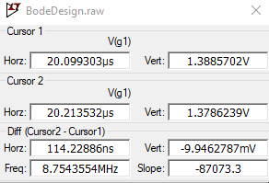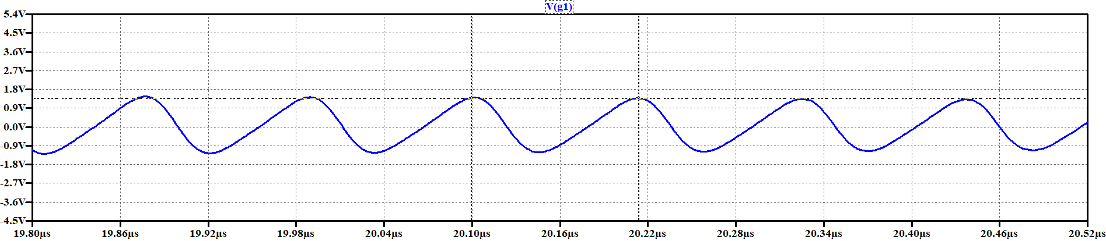

Resonant frequency is measured as 8.75 MHz Insert parallel capacitor to the MOSFET’s drain to source legs so that that frequency drops half of it. The value of the inserted capacitor is 1100 pF that reduces spike frequency by a factor of two. That capacitance is the three times the value of the parasitic capacitance that created voltage spikes.

$$C_{p}=\frac{1100}{3} pF=367 pF (parasitic capacitance)$$

By using this value and the resonant frequency measured as above, the value of the parasitic inductance can be found as below.

$$L=\frac{1}{{\left(2*π*F_{res}\right)}^{2}*C_{p}}=\frac{1}{{\left(2*π*8.75*{10}^{6}\right)}^{2}*367*{10}^{-12}}=9*{10}^{-7}H$$

From these two found values, the characteristics impedance of the resonance can be found as below.

$$Z=\sqrt{\frac{L}{C}}=49.52 Ω$$

From the calculated impedance and capacitor values, the RC snubber circuits component values can be chosen as;

$$R≅Z≅49 Ω$$

$$4*C_{p}<C<10*C_{p}$$

$$1468 pF<C<3670 pF$$

For diode, the same procedure applied to the MOSFET’s can be applied. First resonance frequency of the spike is measured. It is found as 224 MHz Then, by connecting shunt capacitor the value of the parasitic capacitance is found in which the resonance frequency is reduced by a factor of two. Finally, by using the capacitance and resonance frequency values, inductance and reactance values can be found. At the end, almost same of the reactance is selected as snubber resistance, and 200pF capacitance value is selected as the snubber capacitance.

f = 224Mhz

C = 100pF

$$C_{p}=\frac{100}{3} pF=33pF$$

$$L=1.53*{10}^{-8} H$$

$$Z=21.53 ohm$$